1. It is much more convenient to use variables for keys and token as it allows us to be more flexible and reduces repetitive work if something changes.
2. Repetition stands in the way of automation.
3. The main purpose of variables would be not to repeat yourself.
4. 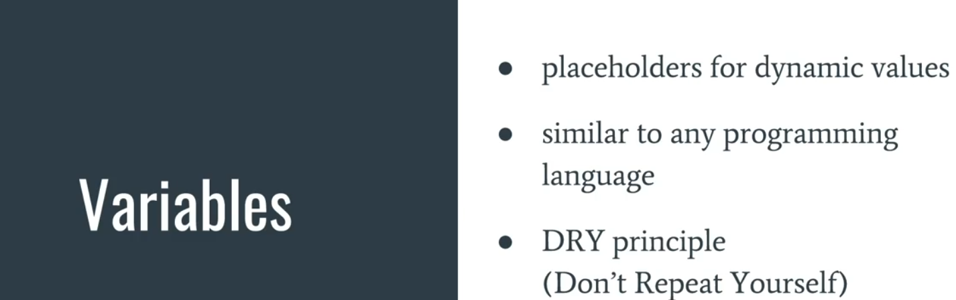
5. If same variable is in global and environment scopes, the environment variable would win as the scope is much narrow.
6. 